LOCAL PENSIONS PARTNERSHIP INVESTMENTS LIMITED
Lancashire County Pension Fund
Pension Fund Committee | 1 December 2017
Responsible Investment Report | Appendix A

Title of Paper | Quarterly Report on Responsible Investment (2017 Q3)
Lead Officer: | Frances Deakin  Responsible Investment Manager  Local Pensions Partnership Investments Ltd  frances.deakin@localpensionspartnership.org.uk
Appendices | Appendix A1 - Climate Change Investment Policy Framework and Guidance  Appendix A2 - LAPFF's Q3 2017 Engagement Report  Appendix A3 - Fuelling the Fire (LGPS Investments in Fossil Fuels)  Appendix A4 - PRI – Outcome of 2017 Reporting Assessment

- Executive Summary

This report provides members of the Pension Fund Committee of Lancashire County Pension Fund (LCPF) with a quarterly update on Responsible Investment (RI) matters.

- Introduction

The Fund's approach to RI has been articulated within an Investment Strategy Statement which confirms that the objective of RI is to decrease investor risk, improve risk-adjusted returns and assist the Fund's adherence to the UK Stewardship Code.

The Fund's preferred approach to RI encompasses four main areas of activity:
- Voting Globally
- Engagement through Partnerships
- Shareholder Litigation
- Active Investing

Responsibility for the practical implementation of the Fund's approach to RI is devolved to Local Pensions Partnership Investments Ltd (LPP I) as LCPF's provider of investment management services. The report which follows provides the committee with an update on RI activity during the period 1st July to 30th September 2017 plus insight on current and emerging issues.

- Voting Globally

Through its investment in the LPP I Global Equities Fund (GEF) LCPF owns units in a pooled fund which invests in listed companies globally. Investors in the GEF delegate the control and exercise of shareholder voting to LPP I as part of arrangements which accommodate a pooled fund structure and associated ownership arrangements. This reflects that clients who hold units in the GEF are beneficial owners in common but do not directly own underlying securities.

LPP I exercises shareholder voting rights for the GEF centrally rather than delegating voting to individual asset managers. Decisions are taken in line with protecting the collective best interests of client pension funds as institutional investors and take account of voting recommendations from an external provider of proxy voting and governance research. Institutional Shareholder Services (ISS) provide voting recommendations in line with applying a Sustainability Voting Policy designed to ensure the consideration of ESG factors within analysis. LPP I review voting recommendations and take the final decision on all voting.

In the third quarter of 2017 shareholder voting headlines for the GEF were as follows:
Total company meetings taking place | 18
Total resolutions (management and shareholder proposals) | 218
Total company proposals in the period | 212
Total shareholder proposals in the period | 6
Company Proposals
Voting was in line with Management recommendations | 196 | 92%
Voting was against Management recommendations | 16 | 8%
Shareholder proposals supported by LPP I | 3 | 50%

The table below summarises resolutions by type and indicates the subject of shareholder resolutions seen in Q3.
Resolutions by Type | Number of proposals
Antitakeover Related | 3
Capitalization (Share Issuance/Repurchase) | 25
Director Related (nominations) | 123
Remuneration | 21
Reorganisation & Merger Related | 2
Routine/Business | 38
SH - Compensation Related | 1
SH - Director Related | 3
SH - Health/Environmental | 2
Total | 218

LPP voted against management resolutions in 16 instances, 13 of which were at the AGM of Compagnie Financier Richemont SA (Accessories & luxury goods). LPP opposed Richemont increasing the maximum remuneration of directors on the grounds that the current level is already high by market standards.

LPP also voted against the election/re-election of 11 directors on the grounds of a lack of independence. This echoed a similar position at the 2016 AGM when LPP opposed nominees on the same basis. No voting results have been released by the company from which it is possible to assess levels of shareholder support/dissent at either the 2016 or 2017 AGMs.

The Swiss Code of Best Practice for Corporate Governance (updated in 2014) recommends that the majority of any board should be composed of independent, non-executive members. ISS considered that of 14 Non-Executive Directors nominated by Richemont in 2017, only 7 are independent.

Detailed analysis shows that the level of independent Board member representation is improving over time, something which becomes apparent by reviewing the proportion of independent directors on key bodies as follows:
The Board (up from 16% to 37%)
Nomination Committee (up from 14% to 47%)
Audit Committee (up from 0% to 40%)
Compensation Committee (up from 0% to 100%).

At the AGM of Vtech Holdings Ltd (world’s largest manufacturer of cordless phones) LPP opposed 2 management resolutions; one on the issuance of equity/equity linked securities (shares) without pre-emptive rights and another on the re-issuance of repurchased shares. Opposition centred on the fact that, taken together, the two resolutions would allow the Board to issue more than 10% of share capital. ISS advice is that the aggregate share issuance limit (inclusive of share reissuance limit, if any) should be no more than 10 percent. Pre-emption gives existing shareholders preferential status, often conferring the right to purchase additional shares in a company before these are made available for purchase by the general public.
In Q3 LPP supported 3 shareholder resolutions at 2 AGMs (against the advice of management). These were as follows:
Environmental
Saputo (packaged foods & meats) – LPP supported a shareholder proposal that the Company disclose how it incorporates environmental objectives into the evaluation of the performance of its executive officers.
The proposal failed, 24 % of votes were in favour.
Darden Restaurants Inc. – LPP supported a shareholder proposal that Darden Restaurants adopt an enterprise-wide policy to phase out routine uses of medically important antibiotics in meat and poultry sources, and report to shareholders on the potential timetable and measures for implementing the policy.
The proposal failed, 13 % of votes were in favour.
Corporate Governance
Saputo (packaged foods & meats) – LPP supported a shareholder proposal that the board of directors adopt a policy for the implementation of an advisory vote on executive compensation.
The proposal failed, 31 % of votes were in favour.
Members are able to view details of voting for all meetings via the LPP website where quarterly reports for the GEF are made publicly available.
https://www.localpensionspartnership.org.uk/what-we-do/investment-management

- Engagement through Partnerships

LPP I regularly participates in collaborations which aim to make progress on commonly held issues and both represent and augment the collective influence of institutional investors. Key partners include the Local Authority Pensions Fund Forum (LAPFF) the Pensions and Lifetime Savings Association (PLSA) the Principles of Responsible Investment (PRI) the Institutional Investor Group on Climate Change (IIGCC) and the UK Pension Fund RI Roundtable.

LAPFF
LAPFF has long been LCPF's preferred engagement partner and recently the Fund nominated its Governance & Risk Officer as a key contact for future interactions with LAPFF. This is a decision which will encourage a more direct relationship with the Forum, rather than one which is primarily maintained by LPP I.

LAPFF's most recent quarterly Business Meeting took place on 27 October 2017. The Fund was represented by the Governance and Risk Officer and County Councillor Charles Edwards. Headlines from the meeting included the following matters:

- Climate Change Investment Policy Framework and Guidance
(Appendix A1)

LAPFF has produced a Climate Change Investment Policy Framework and accompanying Guidance for LGPS Funds which is intended to encourage/assist them to formally identify and publish their approach to the management of climate change risk.

Following a process of consultation, feedback and review involving Forum members and the LGPS Cross Pool Collaboration Group's RI Sub-Group, final versions were presented for approval at the October Business Meeting. The Framework has subsequently been published on the LAPFF website and is publicly available. A copy appears at Appendix A1.

The Framework is deliberately focused on best practice and includes caveats that LGPS Funds at an early stage of recognising climate change as an investment risk will initially need to identify what is realistic and attainable whilst working towards more the more comprehensive standards recommended. The Framework provides model wording for inclusion in Policy statements and is also a good source of guidance and information, providing insight on some key initiatives including the Taskforce on Climate related Financial Disclosure. A confidential Guidance tool has been developed by LAPFF as an additional resource and this will continue to be kept updated over time kept "live". This Guide will only be available to LAPFF members and will be accessible via the secure member only section of the LAPFF website.

LPP I has been involved in the evolution of the LAPFF Framework and Guidance tool and will be offering insights on potential action points for LCPF as part of referencing and reflecting the framework within ongoing advice and support.

- Tax Strategy Reporting (FTSE 50)

The Business meeting received an informative presentation from Richard Murphy – an external advisor to LAPFF on tax matters and a key engagement partner in the forum's Corporate Tax Transparency Initiative. Richard and his team at City University have been undertaking research on tax reporting practices among the FTSE 50 as assessed against new tax reporting legislation in the UK (which includes Country by Country Reporting) and tax reporting practices in the banking and insurance sectors.
A report on tax reporting practices among the FTSE 50 was presented to the meeting.
A second report on the tax practices of banks and insurance companies is forthcoming.
The meeting received a proposal to provide financial support to publish and publicise the FTSE 50 report which was duly agreed by members.
Richard's presentation covered the findings of latest research and his wider activities in association with the Fair Tax Mark. This is as an accreditation scheme which recognises businesses that are good taxpayers. It is the only scheme of its kind in the UK, and describes itself as "bridging the gap between corporate responsibility and the wider tax justice movement".
- LAPFF Q3 Engagement Report (Appendix A2)

The LAPFF engagement programme reflects the Forum's assessment of key priorities from across the collective equity holdings of LAPFF members. On a quarterly basis LAPFF provides Forum members with a summary of the engagement activities undertaken on their behalf. LAPFF Quarterly Engagement reports were previously marked confidential with circulation restricted to Forum members but within the last quarter reports have been re-classified and are now made publicly available via the LAPFF website.
LAPFF's Q3 2017 Engagement Report is attached at Appendix A2.

Quantified across thematic topics, engagement activity by LAPFF was as follows:
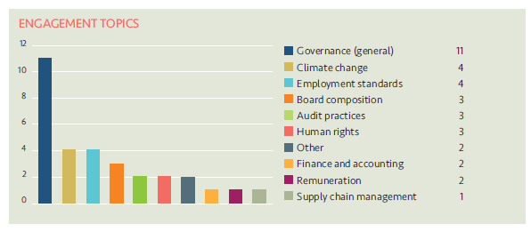

The companies engaged with and the topics raised with them by LAPFF were as follows:

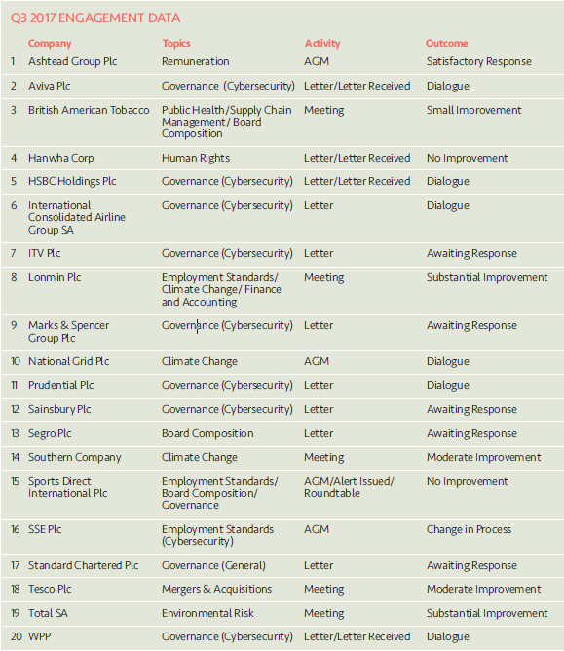

Principles of Responsible Investment (PRI)
- Engagement on Cyber Security

As detailed in the last RI report to committee, the PRI is co-ordinating an investor engagement on Cyber Risk. The project aims to improve risk management from the Board’s perspective and is to be targeted from a governance point of view. Cyber Risk is recognised as an area of technical complexity and Boards need to be fully aware of the risks this brings, and have the knowledge to proactively question management, and ensure the risks are being actively monitored across the organisation.
Whilst it is unorthodox (since LPP is not a PRI member in its own right) LPP I has been allowed to participate on behalf of LCPF and LPFA as signatories and clients on this occasion.
Since the Committee's last meeting, a first call has taken place between PRI and the investors who have joined the engagement. Discussions involved agreeing Terms of Reference and the scheduling and organisation of forthcoming activities.
- Shareholder Litigation

LPP I employs Institutional Protection Services (IPS) as an external provider of litigation monitoring services to ensure shareholder litigation cases affecting securities owned by the GEF are known about, claims are filed in a timely way and progress is monitored and followed up with Claims Administrators. In addition, IPS monitor cases relating to shares held by LCPF in the period before the Fund pooled its listed equity investments from November 2016. Litigation can arise quite some time after shares have been sold and monitoring new cases and referring back to historic holdings records to establish rights of ownership is an ongoing task.

IPS provide LPP I with monitoring information on a quarterly basis detailing the number of cases investigated. The monitoring report provided for Q3 2017 confirmed that
10 potential new cases where the Fund might have an entitlement to join an action were detected in the period July to September 2017. Further analysis discounted 7 of these and the remaining 3 cases currently remain subject to further review.

- Active Investing

This section of the RI report is dedicated to updating the Committee on new developments within stewardship and RI and interpreting these within the context of the Fund's responsibilities and interests.

Fuelling the Fire (LGPS Investments in Fossil Fuels) – Appendix A3

Subtitled "A new report on the local government pension scheme and fossil fuels" Fuelling the Fire was published online on Thursday 9th November by GoFossilFree, an umbrella organisation representing 350.org, Friends of the Earth, Platform and Community Reinvest. https://gofossilfree.org/uk/fuellingthefire/
The report presents the results of re-visiting the issue of LGPS exposure of LGPS after a two year break since a first set of figures was published in September 2015. The holdings data used to produce calculations is described as being based on the end of 2017 financial year (presumably March 2017) and retrieved from responses given to Freedom of Information requests.
The new report presents an analysis and league table of funds showing their direct and indirect interests in the world's 200 biggest extractors of fossil fuels. The outcome of comparison is the headline finding that whilst the value of LGPS investments in the sector has increased, the aggregate proportion invested in fossil fuels has decreased.
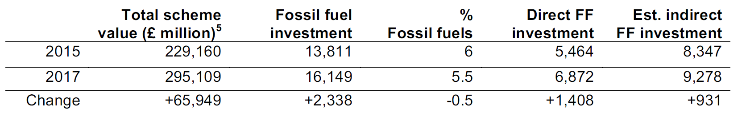
LCPF is identified within the list of 10 Funds with highest total investment in fossil fuels (£340m) which is a simple measure of quantum. LCPF does not feature within the table of funds with the highest proportion of their assets in fossil fuels, the highest being Greater Manchester at 10.2%. Lancashire's figure is quoted in the league table as 4.8%.

The Local Pensions Partnership is identified as the LGPS pool with the lowest level of exposure (2.5%) based on a calculation which includes Berkshire, LCPF and LPFA assets.

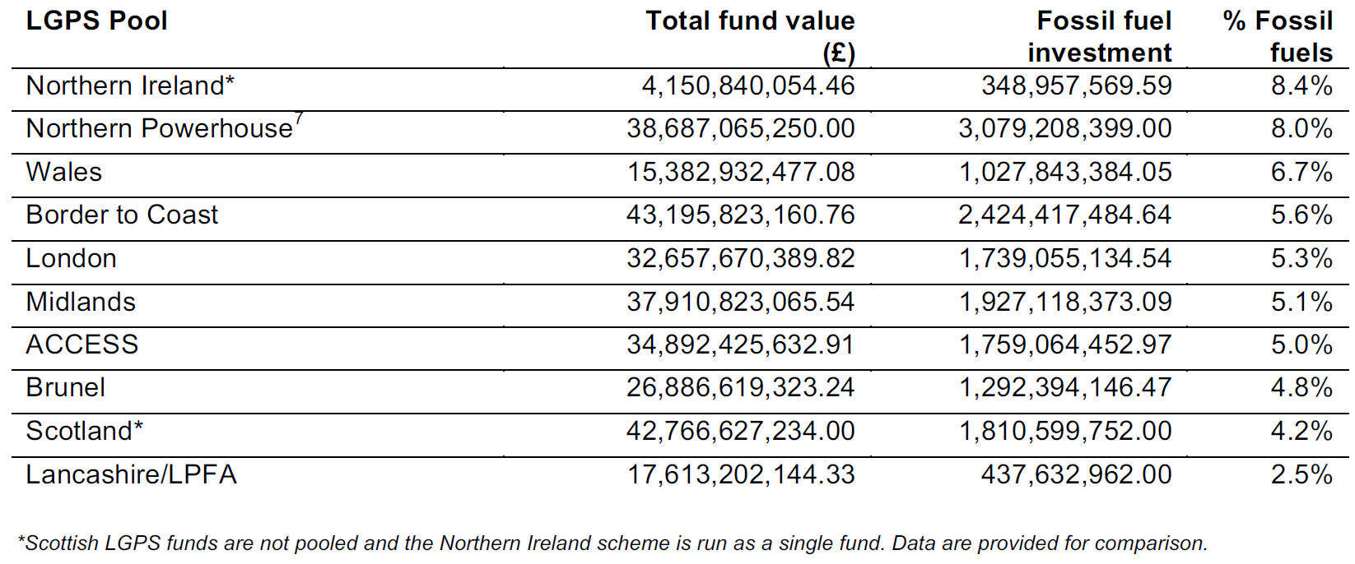
The publication of Fuelling the Fire was accompanied by a blanket email campaign encouraging constituents to send a standard email to their elected representatives asking them to support the divestment of their Local Government Pension Fund from fossil fuels. A number of elected members at Lancashire County Council have been recipients of this email to which a standard response has been produced (agreed by the Head of Fund and the Chair of the Pension Fund Committee).
Review of the UK Stewardship Code

RI practitioners from each of the LGPS pools were recently invited to meet with the Financial Reporting Council (FRC) to consider a proposed review of the UK Stewardship Code. The Code has not been refreshed since 2012 and it is acknowledged that stewardship best practice has evolved in the intervening period. A meeting between the FRC and RI Sub-Group members took place on 13th October 2017 and occasioned an initial exchange of views.

It was clarified that a review of the Stewardship Code will not involve a formal consultation of the type due to be issued shortly on the Corporate Governance Code but will feature an exercise in gathering ideas on how the Code could usefully be developed. The responses received will be the basis for the FRC producing an updated draft of the Code which will then occasion a full consultation before any new version of the code is adopted.

Workforce Disclosure Initiative (WDI) – update

LPP I is a named supporter of the WDI, a project which aims to "bring institutional investors together behind a call for comparable workforce reporting by publicly listed companies on their global operations and supply chains". 88 institutions managing $8.6 trillion in assets are named supporters.

ShareAction are managing a pilot survey for the WDI programme and have circulated a detailed questionnaire to a subset of 75 companies. This seeks information on workforce composition, workforce development, and worker engagement. The intention is that the survey's coverage will be expanded over time to encourage better corporate disclosure to a standard format.

ShareAction have produced two Signatory Bulletins (Sept and October 2017) to update supporters. These confirm that the deadline for survey responses has been extended and it is expected that 33 companies will respond in total (44%). Responses will be analysed in order to produce a short summary of findings for supporters due out in late December. An investor roundtable in January 2018 will allow supporters to discuss initial findings, share ideas on investor engagement and discuss next steps, including which countries and regions to target in the 2018 cycle.

- Other Matters

Principles of Responsible Investment – Outcome of 2017 Reporting Assessment
(Appendix A4)

As reported to the Committee at its June 2017 meeting, the Fund formally reported to the Principles of Responsible Investment (PRI) for the first time in 2017 after becoming a PRI signatory in March 2015.

The annual reporting deadline is 31 March and reporting is completed entirely online. A detailed array of indicators require a response, designed to capture the signatory's overall approach and specific efforts/ activities undertaken in the previous 12 months. The outcome of the annual reporting process is a Transparency Report for each signatory which in Lancashire's case is a composite of responses to more than 60 individual indicators. The report is made publicly available via the signatory directory on the PRI website. https://www.unpri.org/signatory-directory/

In addition, each signatory receives a confidential Assessment Report which confirms the PRI's evaluation of their reporting against an underlying assessment methodology and their position relative to a peer group. Assessment Reports are not made public by PRI but signatories can opt to publish them (subject to a caution from PRI about misrepresentation as a result of using edited highlights). Assessment Reports aim to provide signatories with the challenge of an external review process which includes objective scoring which helps to identify areas for future focus and improvement.

The 2017 Assessment Report for LCPF is attached at Appendix A4. The scoring approach accommodates a mark from A to E against 8 possible segments. LCPF was not required to report against 3 of the segments in 2017 and scoring is therefore across 5 segments in total. The summary Scorecard (p5) shows good scores were received across the board, only one score being below the segment median for the peer group.

The Fund received its lowest rating (C) for Direct, Listed Equity Active Ownership. This segment covers responses to questions on engagement and proxy voting which was the most challenging section of the annual reporting framework to complete for a number of reasons.

First, reporting is from the perspective of LCPF as an asset owner PRI signatory and not merely reviewing what service providers such as LPP I and LAPFF do on the Fund's behalf. Questions probe the role, standards, arrangements and participation the Fund has in engagements and stewardship.

Second, a number of voluntary indicators form part of the maximum scoring available for this segment and where these are not completed (as in 2017) this immediately reduces the score achievable.

Third, the timing of the reporting process was material, responses were being produced in March 2017 looking back over the prior 12 months. This was a formative time for the partnership and prior to new arrangements being put in place.

In terms of action points, the observations made to the Committee back in June remain pertinent.

Some specific learning points have arisen from the experience of working through the detailed reporting framework. One of the greatest difficulties was in clearly defining a demarcation between LCPF as an asset owner signatory and LPP as a provider who fits the PRI's definition of a fiduciary manager. It is LCPF rather than LPP which is the PRI signatory, but there are currently limited places in which the Fund formally sets out RI requirements and how they inform what is required of LPP in terms of stewardship activity and monitoring against this. For example the Fund's Statement of Investment Principles (SIP) which contained a level of detail on the Fund's preferred approach to RI was superseded by an Investment Strategy Statement in October 2016 which lacked this detail. Similarly, the timing of the redrafting of the Fund's statement of compliance with the UK Stewardship Code meant it could not be referred to in detail within the 2017 return.

Some of these points are being addressed currently as part of the deliberations the Committee's RI Working Group.

